Development of a SysTick Timer-Based Periodic LED Task Scheduler Without Using Software Delays
Step 1: Create a New Project for Nucleo-H753ZI
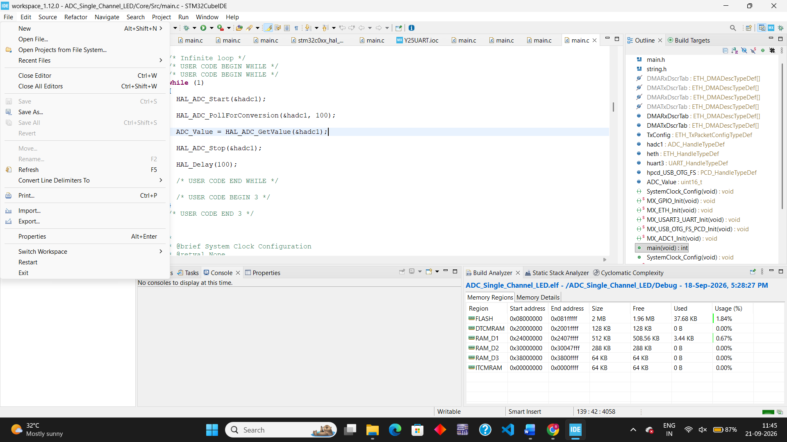
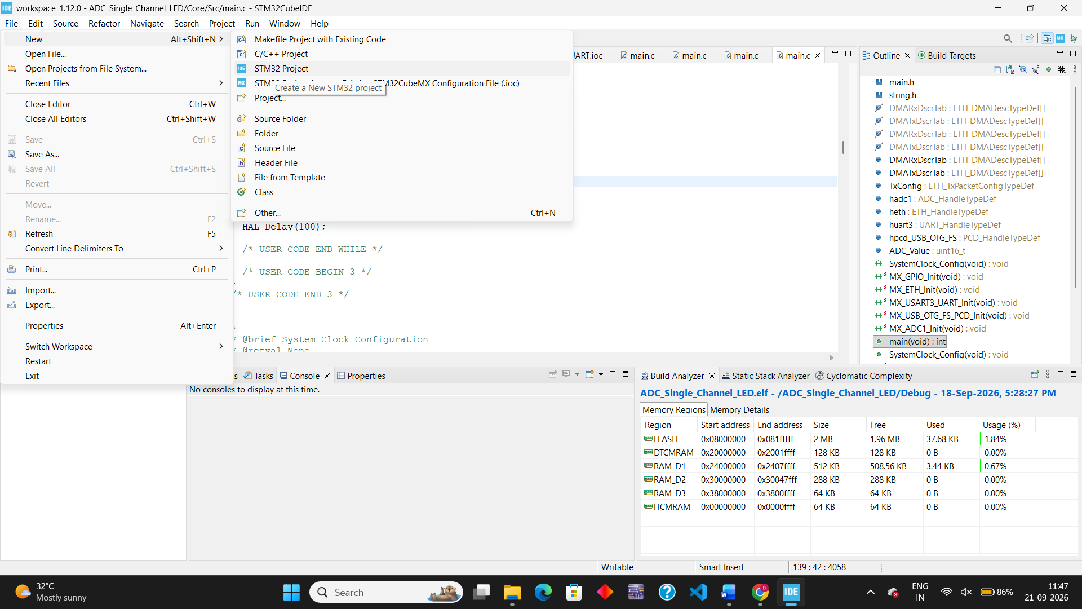
Go to filenew
New STM32 Project
Click on the STM32 Project to create a new project
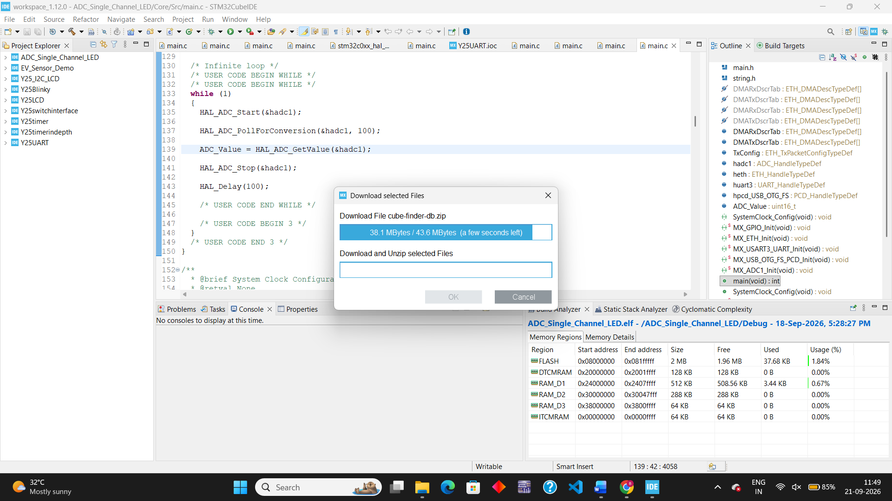
File New STM32 Project

Now here the target selector will be opened
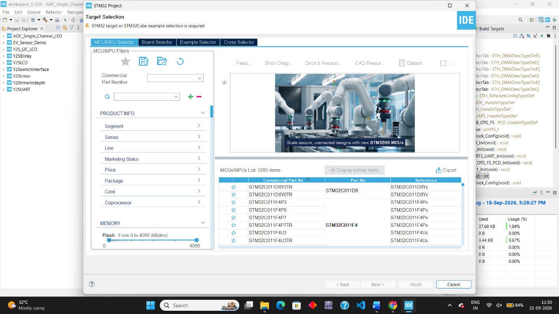
Go to click on Board Selector
Enter the board configuration for example now the present experiment is done with NUCLEO-H753ZI
Enter that in commercial Part Number
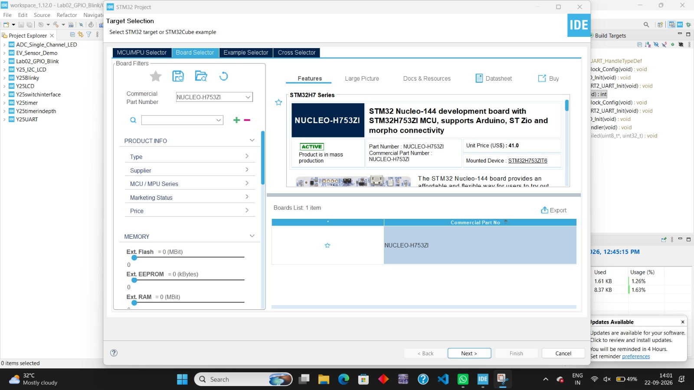
Now click on the NUCLEO board as shown and click Next
After clicking next we get a page Enter the Project Name example here I kept Lab02_H753_LED_Blink.

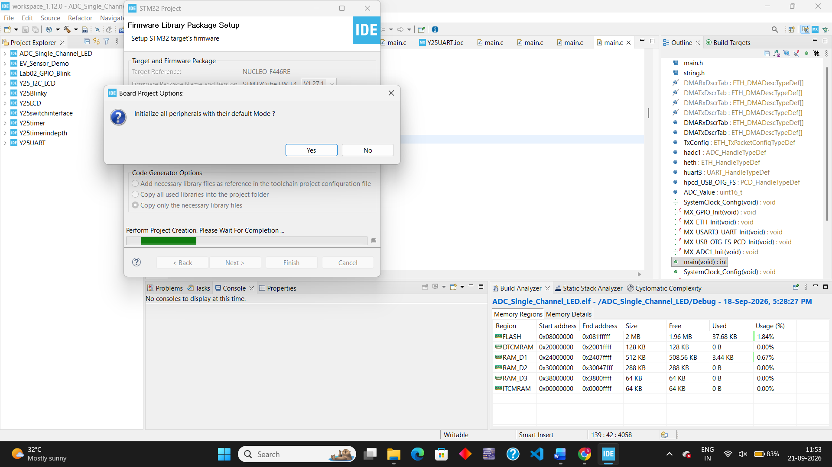
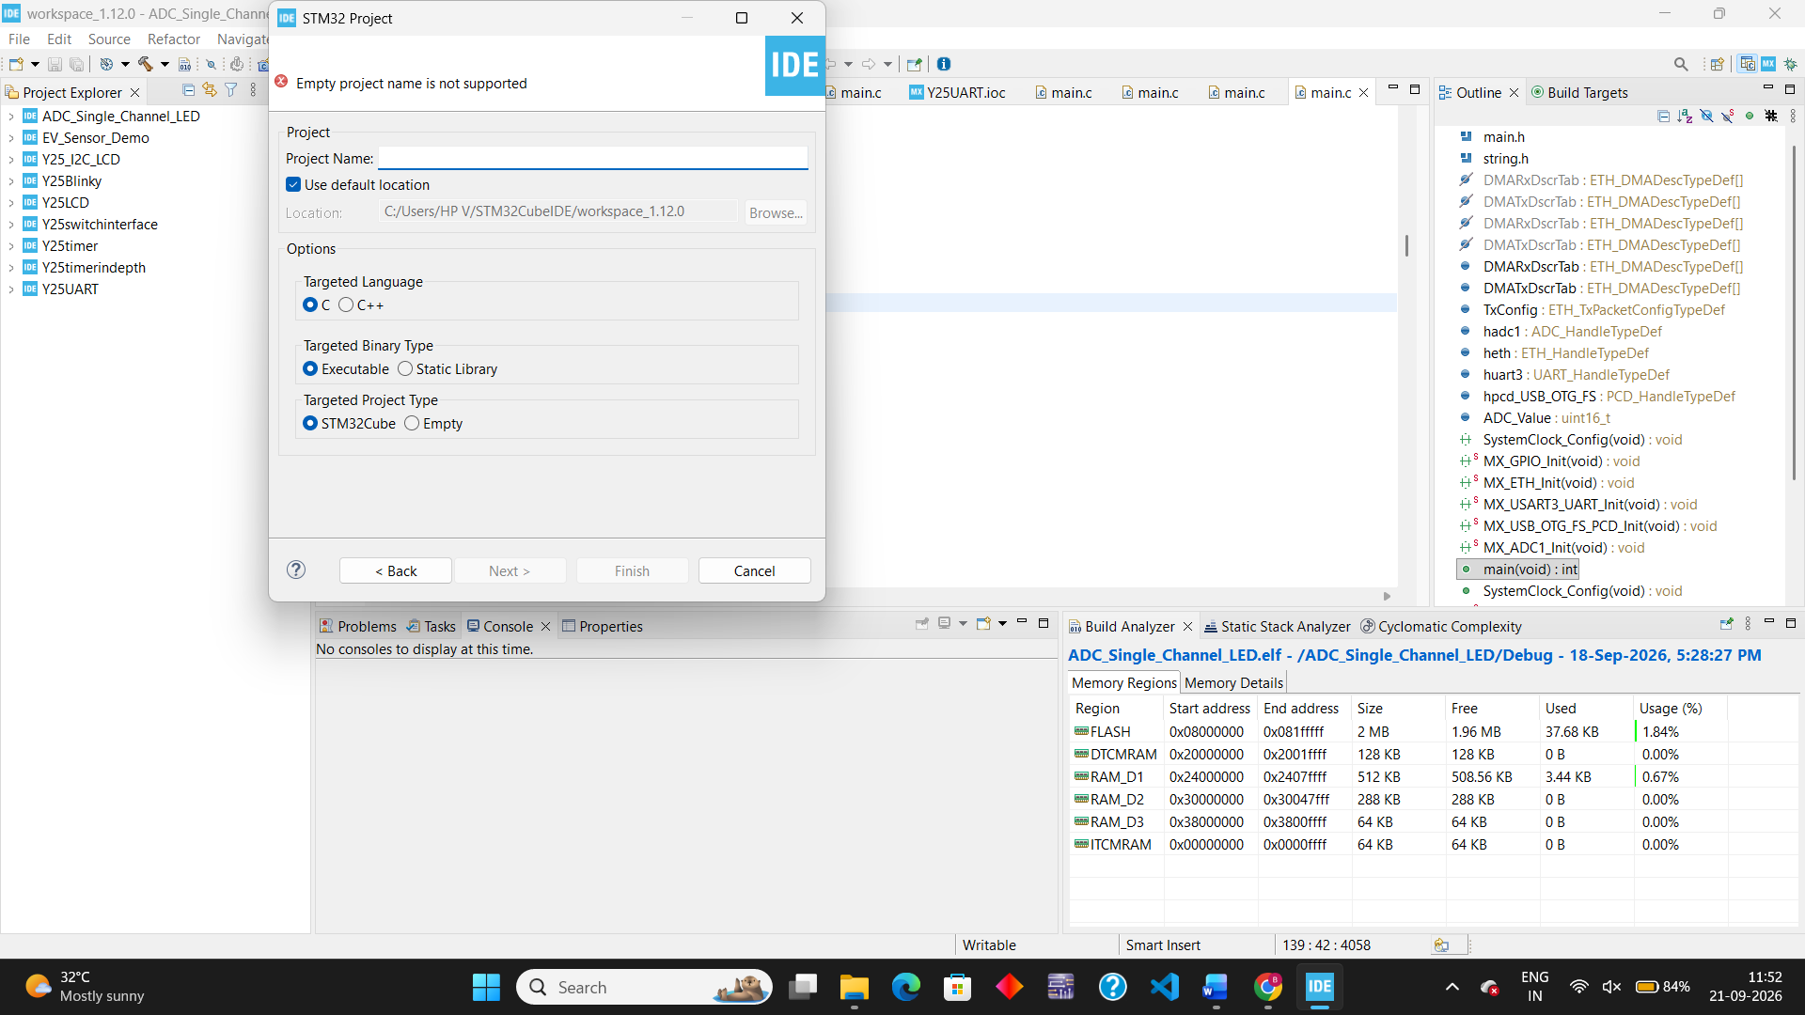
Click on next and then Finish
Click yes for the all peripheral if it appears

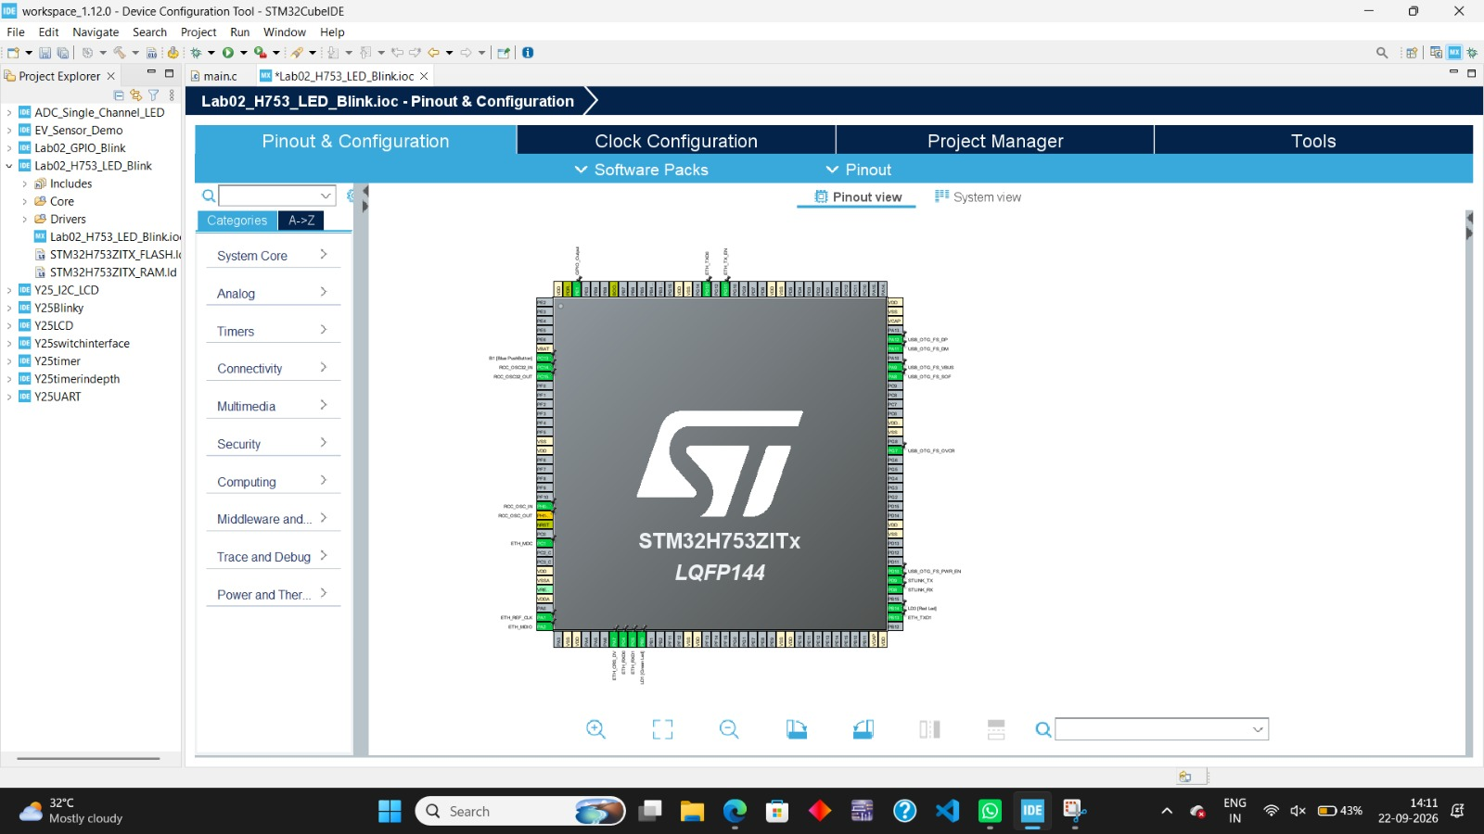
The new project is created
Now unable the required pins
In the graphical Pinout View, look for pin PE1

Click on pin PE1 and select GPIO_Output.
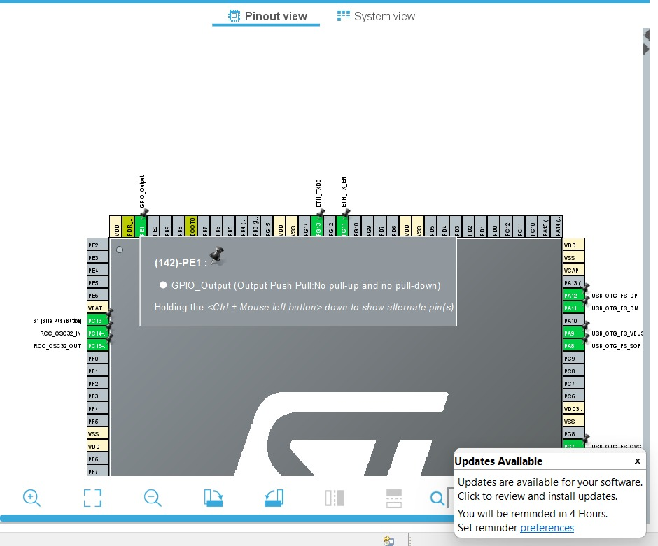
How to enable? PE1GPIO – OUTPUT
Click on the PE1 in the board and select the GPIO- OUTPUT

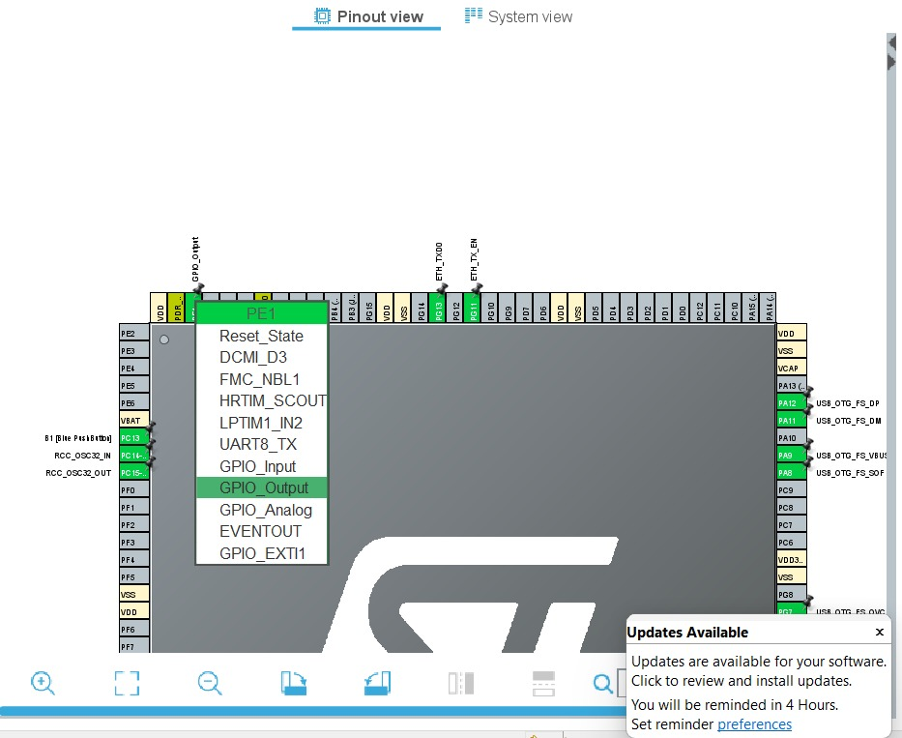
Go to the System Core menu on the left pane and click on GPIO.
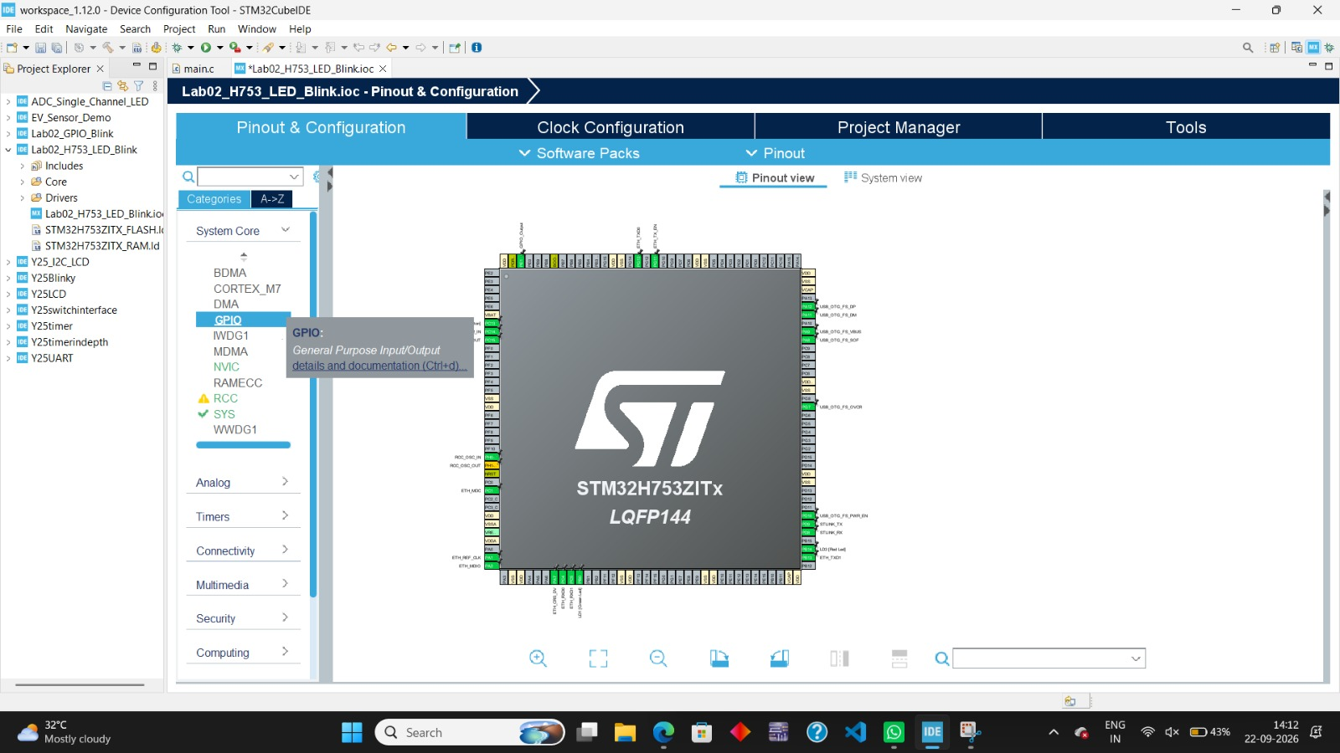
Click on PE1 in the pin list table at the bottom to view its configuration parameters.
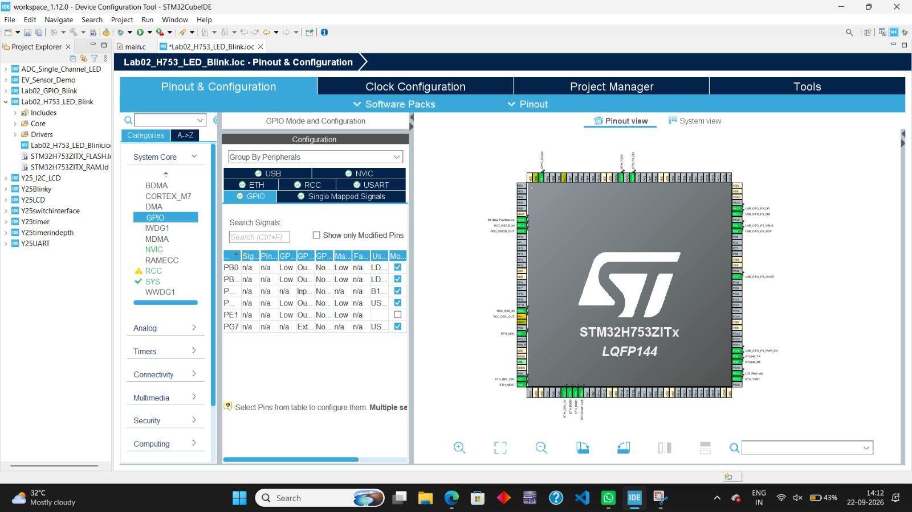

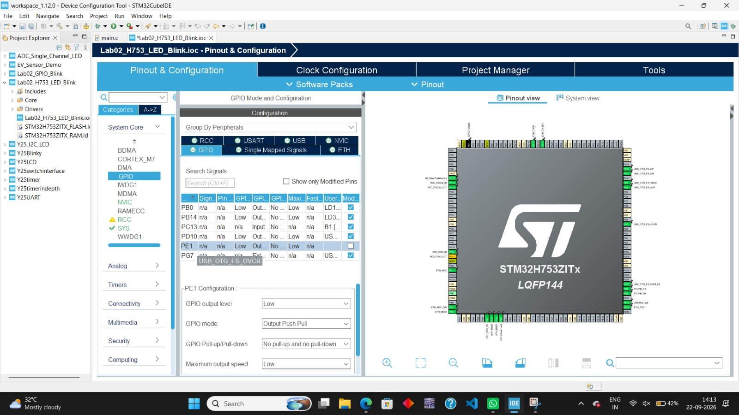
After clicking on PE1 we get the PE1 Configuration

- GPIO output level: Low
- GPIO mode: Output Push Pull
- GPIO Pull-up/Pull-down: No pull-up and no pull-down
- Maximum output speed: Low (or Medium for faster transition speeds)
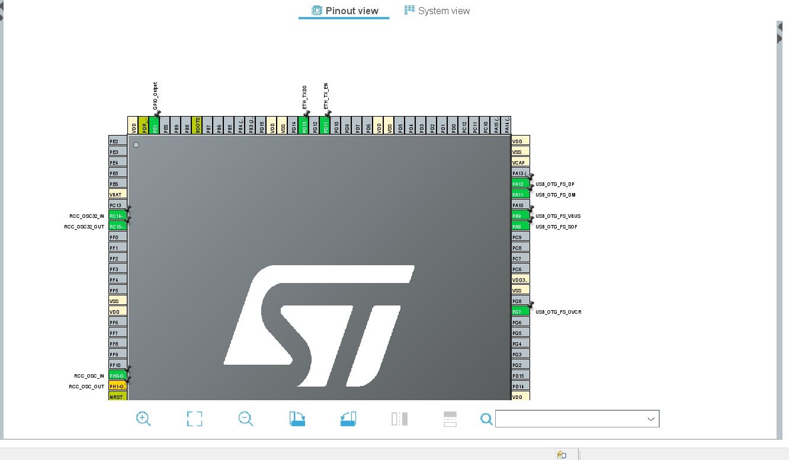

- Click on PC13 and select GPIO_EXTI13.
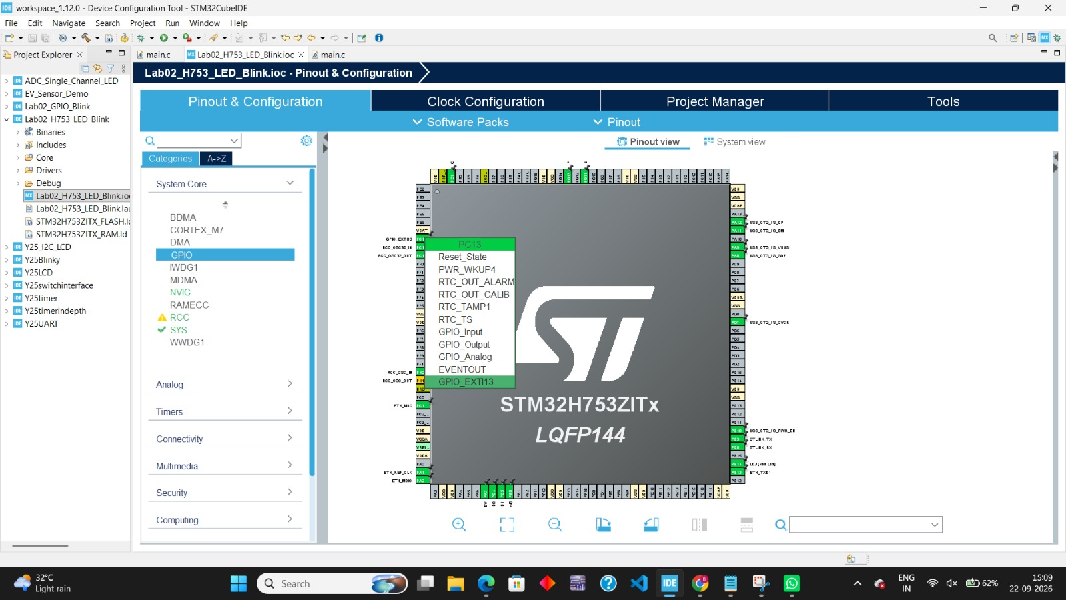
Go to the System Core menu on the left pane and click on GPIO.
After clicking on PC13 we get the PC13 Configuration
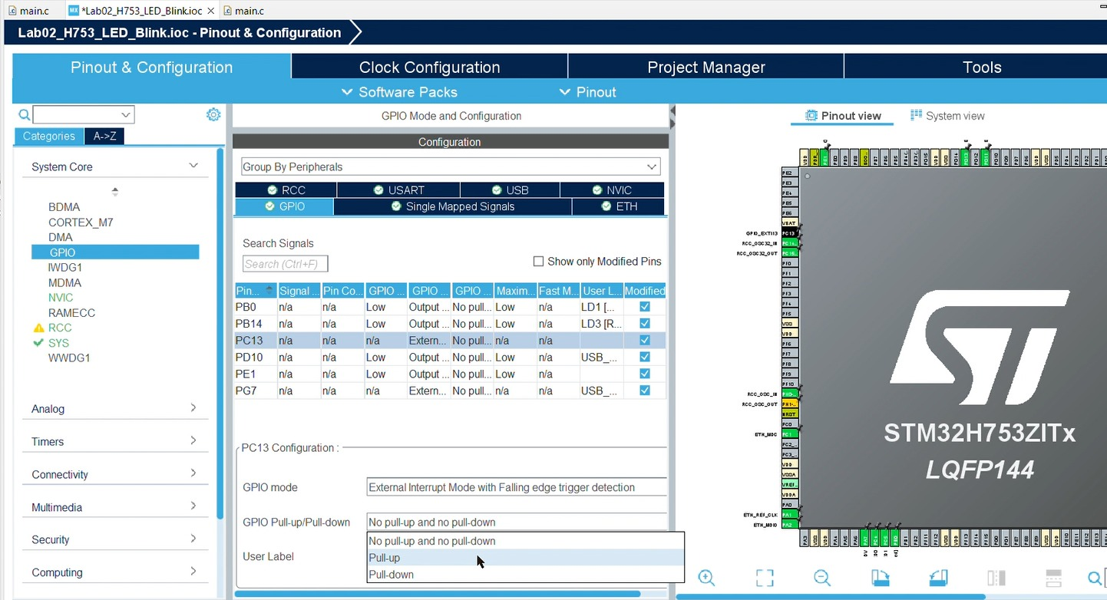
- On the left menu, go to System Core > GPIO.
- Click on PC13 in the lower configuration table:
  - Set GPIO mode to External Interrupt Mode with Falling edge trigger.
  - Set GPIO Pull-up/Pull-down to Pull-up.
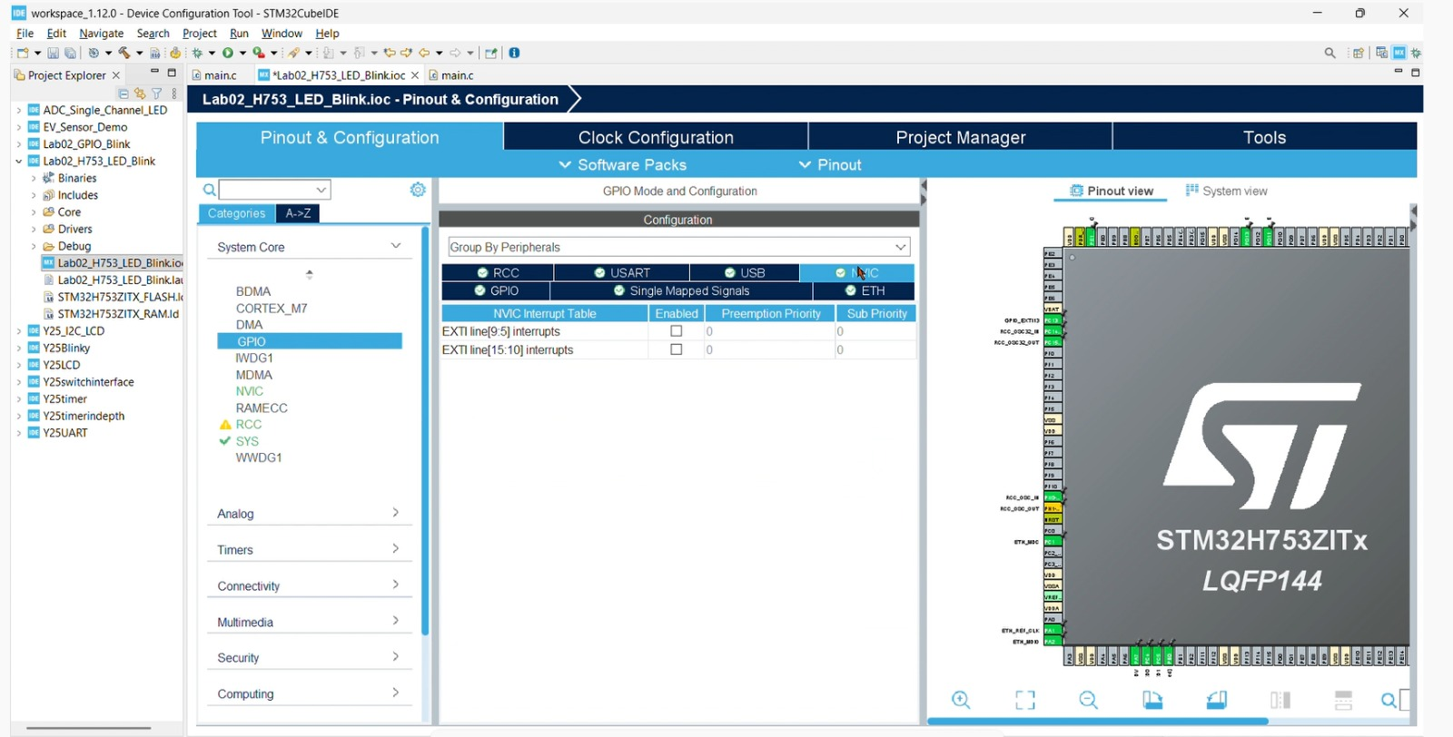

- On the left menu, go to System Core > NVIC.
- Check the box to Enable EXIT line[15:10] interrupts.
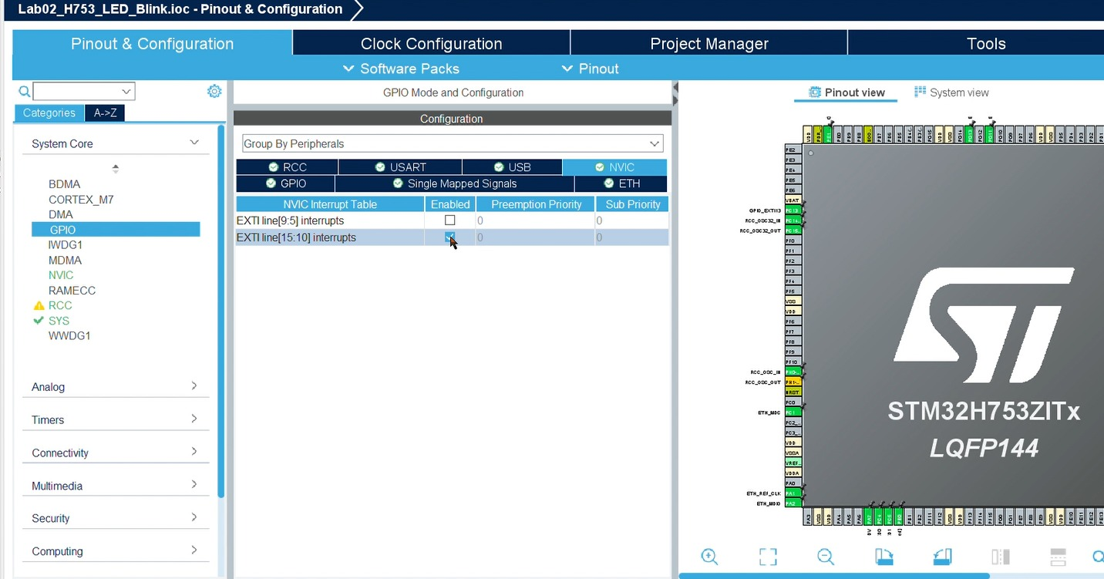

After that save(Ctrl + S) and generate code click yes
Click yes
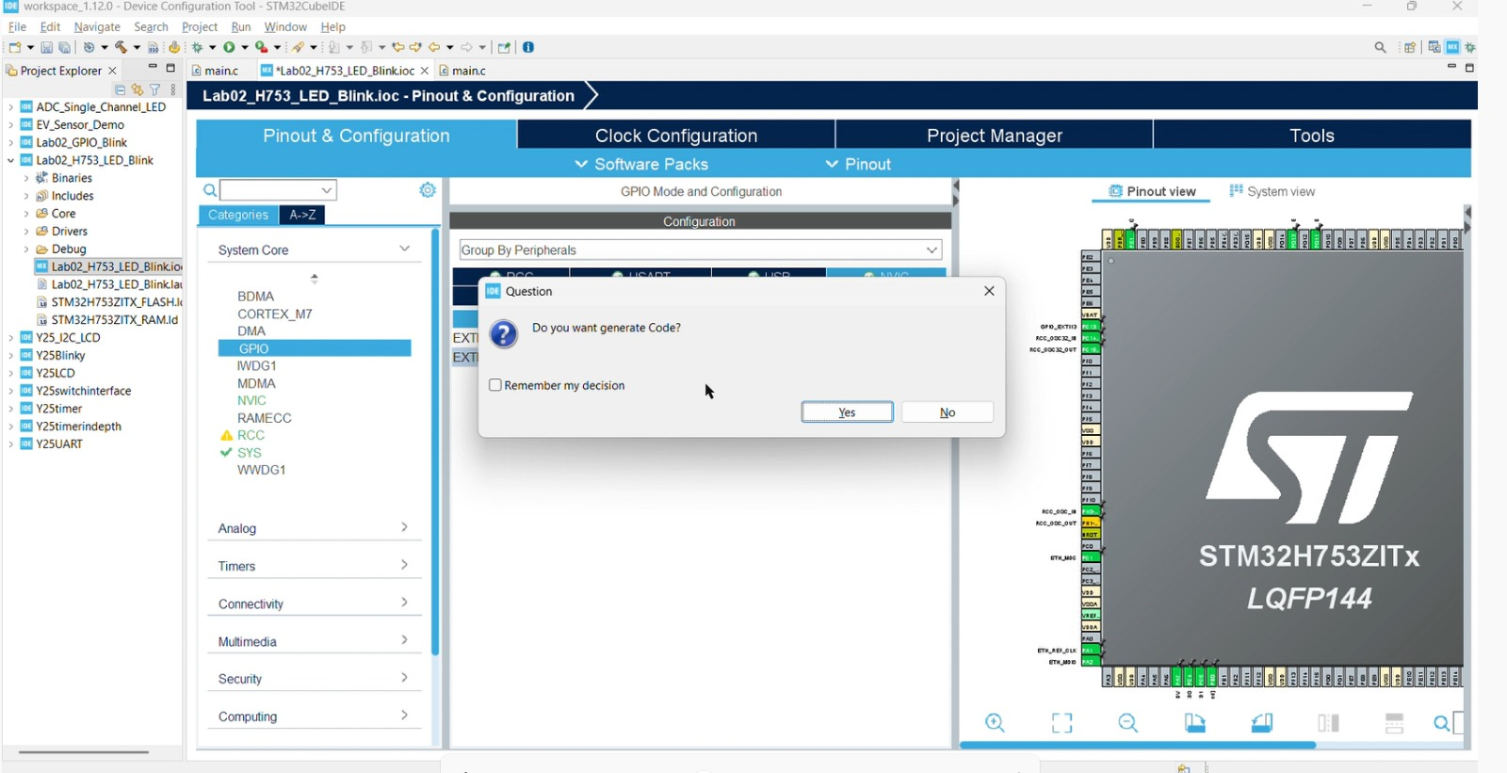
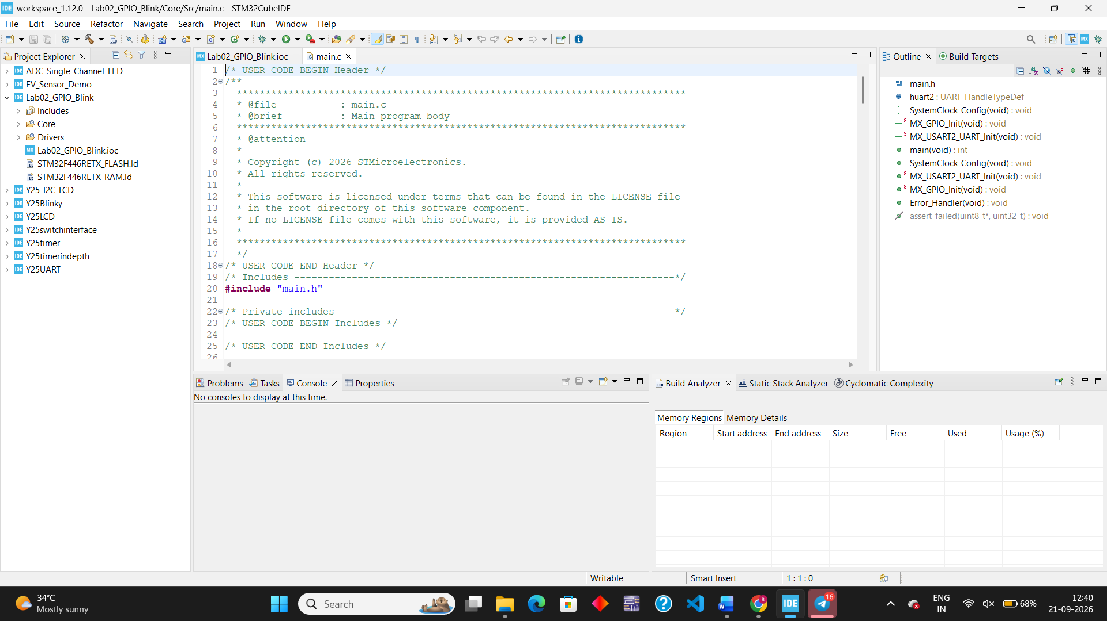
The code is generated will look like this

- Scroll down until you find the while (1) infinite loop inside the main() function.
- Add the toggle and delay lines inside the loop so it looks like this:
Enter the code in the while(1) loop

while (1)
{
/* USER CODE END WHILE */

/* USER CODE BEGIN 3 */
HAL_GPIO_TogglePin(GPIOE, GPIO_PIN_1);
HAL_Delay(500);
}
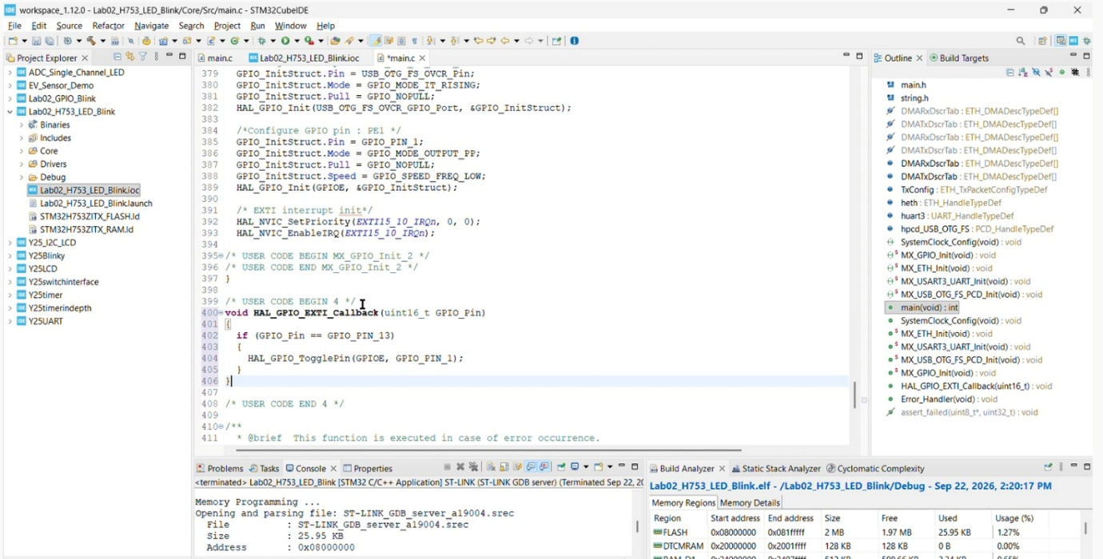
- Scroll down to find the /* USER CODE BEGIN 4 */ section.
- Paste the interrupt callback function below to toggle the LED (PE1) whenever button (PC13) is pressed:

void HAL_GPIO_EXTI_Callback(uint16_t GPIO_Pin)
{
if (GPIO_Pin == GPIO_PIN_13)
{
HAL_GPIO_TogglePin(GPIOE, GPIO_PIN_1);
}
}

Click the Hammer (Build) icon at the top toolbar and make sure the console reports 0 Errors, 0 Warnings.
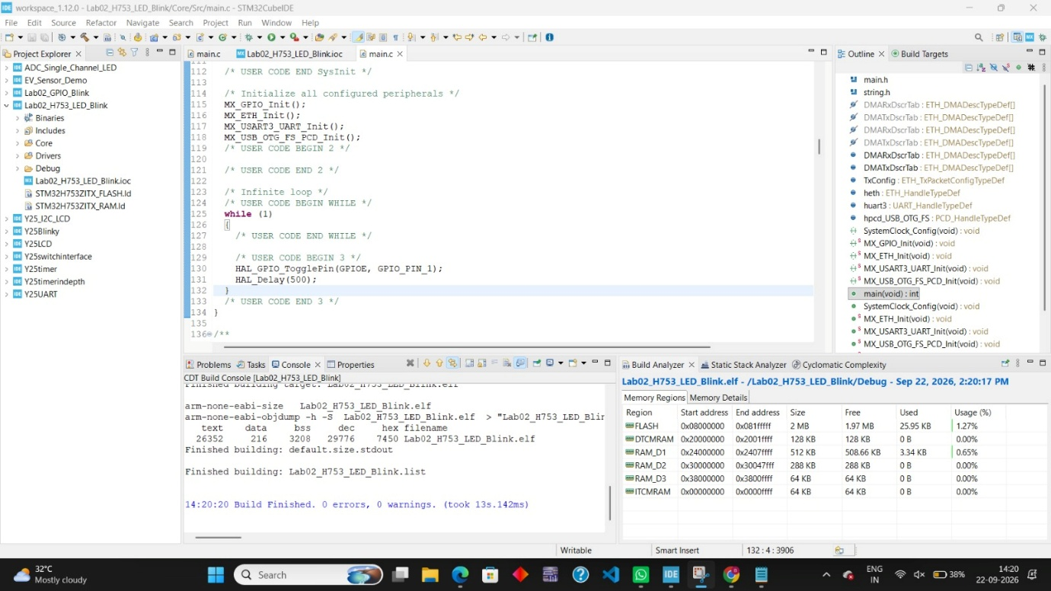

- Connect your Nucleo-H753ZI board to your laptop using the USB cable.
- Click the Run/Debug (Green Play bug icon) button to flash the code onto the board.

